**Meaning of Depreciation**

In simpler terms, depreciation is a way to account for how an asset loses value over time as it's used. This loss in value is spread out over a certain period, which is considered the asset's useful life. The useful life is an estimate of how long the asset will be beneficial.

Depreciation is treated in the accounts as an expense and it reduces the profit for the fiscal year. The depreciation set aside annually is accumulated for the UEL and it is often referred to as accumulated depreciation.

To calculate the depreciation, various factors are to be taken: The value of the asset, the UEL of the asset and the expected value of the asset at the end of its UEL (scrap value). Depreciation calculation can be performed using various methods. For example, there is the straight-line method, declining or reducing balancing depreciation, the sum of the digit depreciation.

**Planned Depreciation**

Planned depreciation reduces the value of the asset systematically over a given planned period, such as one month, one year, etc. Depreciate the value of the asset systematically over its UEL based on plan-defined parameters. This allows you to ascertain the value of the asset at any time during the economic life of the asset. Simply examples of planned depreciation are ordinary depreciation and special depreciation.

**Ordinary Depreciation**

Ordinary depreciation is the planned reduction of a specified given period. When customizing ordinary depreciation, requires to determination of depreciation areas in which to manage ordinary depreciation and the general ledger accounts in which the ordinary depreciation is posted.

**Determining Depreciation Areas**

To determine depreciation areas for ordinary depreciation here is the **SAP Easy Access Menu Path - SAP Reference IMG**:

Financial Accounting (New) ➤ Asset Accounting ➤ Depreciation ➤ Ordinary Depreciation ➤ Determine Depreciation Areas. The Change View “Specify Depreciation Areas for Ordinary Depreciation”: Overview

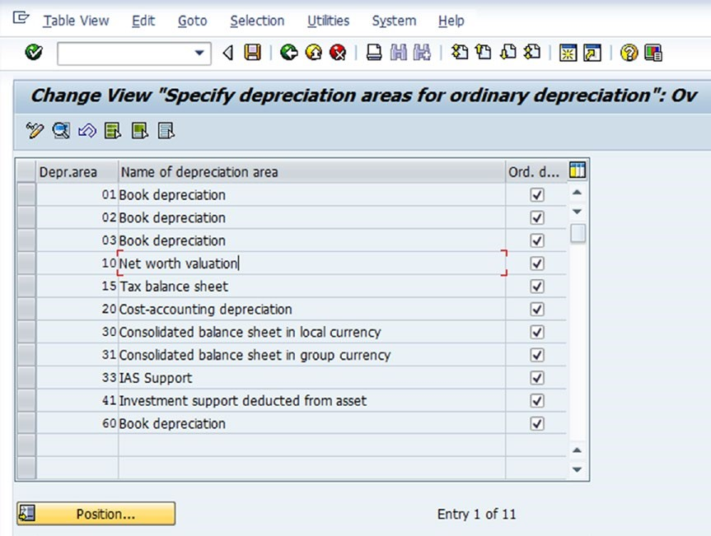

The next step of this activity is to determine the rule for the positive and negative amounts the ordinary depreciation is allowed to have in each depreciation area.

To proceed to the screen that defines the specifications for the respective depreciation area, select a depreciation area (*for example, 01 Book depreciation*) from the list area and click the Details button (*Search Icon*) on the top-left side of the screen. The Change View “***Specify Depreciation Areas for Ordinary Depreciation***”: Detail screen appeared. Here are the four ordinary depreciation for ***positive/negative signs***. The system will automatically default to the ***Only Negative Values and Zero Allowed*** options.

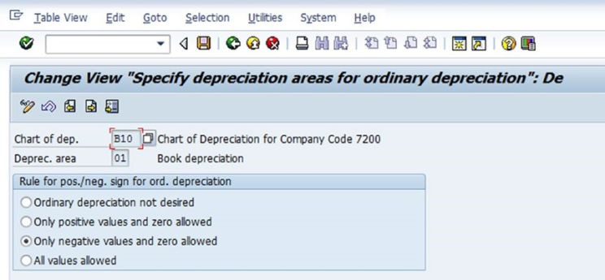

This can override the defaults by simply specifying the option(s) based on the requirements of the company. For example, if a company calculate the positive depreciation of a positive APC (Acquisition and Production Cost), it can specify “***Only Positive Values and Zero Allowed***” as the rule. This specification will then allow the system to ensure that only positive depreciation amounts are allowed in the depreciation area.

**Assigning G/L Accounts**

Simply it is just the determining Depreciation posting accounts. For determination the general ledger accounts in FI where ordinary depreciation in Asset Accounting are posted. Required to assign the general ledger accounts for ordinary depreciation using the **menu path - Reference IMG:**

Financial Accounting (New) ➤Asset Accounting ➤ Depreciation ➤ Ordinary Depreciation ➤Assign Accounts.

**Unit-of-Production Method of Depreciation**

The unit of production depreciation method is quite different from the conventional methods of depreciation, which are based on the passage of time (estimated usage years of an asset).

The unit of production method of depreciation calculation is based on units of activity of expected output or an asset’s usage. For example, the depreciation of a given asset is calculated based on production output in a given period.

As part of the customizing of the unit-of-production method of depreciation, required to define the depreciation key for unit of depreciation and assign the estimated total number of units for the asset and the actual quantity produced for individual depreciation period.

The system will then determine the depreciation amount using the total units, the actual units produced, and the APC or the net book value. APC is the acquisition cost of the asset or the replacement value and the net book value is APC less the accumulated depreciation.

To define the depreciation key and specify the number of units for the depreciation keys for the unit of production method of depreciation, **Menu path - SAP Reference IMG:**

Financial Accounting (New) ➤ Asset Accounting ➤ Depreciation ➤ Ordinary Depreciation ➤ Define Unit-of-Production Depreciation.

* The Change View ***“Company codes”: Overview screen*** is displayed containing the list of existing company codes.
* Select a particular company code as required from the displayed list and double-click the ***Depreciation key*** folder on the left side of the screen. The Display View ***“Depreciation Key”: Overview screen*** has appeared.

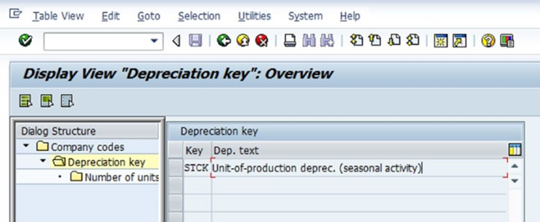

* To assign a number of units to your depreciation key, select the depreciation key ***STCK-Unit-of-production deprec. (seasonal activity)*** and double-click the ***Number of Units*** folder on the left pane of the screen.
* The Change View ***“Number of units”: Overview screen*** has appeared. To enter data on the screen, click on the ***New Entries*** button at the top-left side of the screen. ***The New Entries: Overview of Added Entries screen*** has appeared.

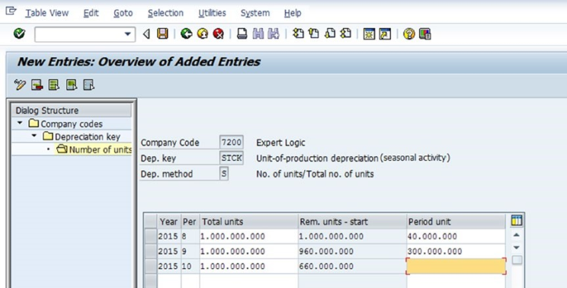

* Required to fill-up the following:

**Year:** Enter the accounting fiscal year the asset relates to.

**Per:** Enter the related accounting period in this field. The accounting period is based on the number of months in an accounting year. This is usually 12 months. *For example,* if your accounting fiscal year is from January to December, January will be period 1, February will be period 2 and so on.

**Total Units:** These are the estimated production units of the asset with which the asset is depreciated.

**Unplanned Depreciation**

Unplanned depreciation allows to apply an unplanned value adjustment due to an unforeseen occurrence of an event resulting in the permanent reduction in the value of an asset.

For example, advancement in technology necessitates a drastic reduction in the value of an asset.

Specifying the depreciation areas for unplanned depreciation will allow the value type to be accepted by the system without issuing an error message when entering related depreciation terms in the asset master record.

To determine depreciation area for your unplanned depreciation , **SAP Reference IMG menu path**:

Financial Accounting (New) ➤ Asset Accounting ➤ Depreciation ➤ Unplanned Depreciation ➤ Determine Depreciation Areas.

The Change View ***“Asset Accounting: Define if Unplanned Deprec.Pos/Neg”: Overview screen*** is displayed. It contains the list of depreciation areas in from chart of depreciation.

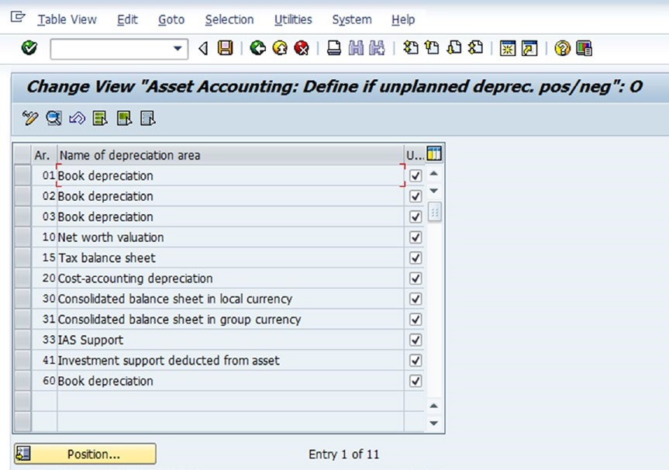

Specify the depreciation areas that need to be managed in unplanned depreciation by clicking the ***UDep*** check box on the right side of the screen.

The next step in this activity is to determine the rule for ***positive and negative signs*** for the unplanned depreciation in each depreciation area. To proceed to the screen where will carry out the specifications for the respective depreciation areas, select a depreciation area (for example ***01 Book depreciation***) from the list of depreciation areas and click Details ***Search Icon*** at the top-left side of the screen.

The Change View ***“Asset Accounting: Define if unplanned deprec. Pos/neg”: Overview screen*** is displayed containing four rules for the positive/negative sign for ordinary depreciation option. The system automatically defaults to Only Negative Values and Zero Allowed. This option will ensure that only negative depreciation amounts are allowed in the depreciation area in question if company want to calculate the negative depreciation of a positive APC.

It can override the defaults by simply specifying the option of the choice based on the requirements of the company. For example, if a company want to calculate the positive depreciation of positive APC, that can specify Only Positive Values and Zero Allowed as the rule for ordinary depreciation for the respective depreciation area.

This specification will then allow the system to ensure that only positive depreciation amounts are allowed in the depreciation area.

***Assigning G/L Accounts***

In this activity, Determine the general ledger accounts in FI where unplanned depreciation in Asset Accounting are posted.

That can assign or determine the general ledger accounts for ordinary depreciation using the menu path - SAP Reference IMG:

Financial Accounting (New) ➤ Asset Accounting ➤ Depreciation ➤ Unplanned Depreciation ➤ Assign Accounts.

**Defining Transaction Types for Unplanned Depreciation**

Normally, unplanned depreciation values are corrected manually in SAP when posting in asset accounting. When posting unplanned depreciation in asset accounting, a transaction type for unplanned depreciation is mandatory. Transaction types identify individual business transactions posted in asset accounting. SAP comes with standard transaction types that can use. It is recommended that stick to the standard transaction types supplied by SAP. So do not have to do anything in this activity.

**Valuation Methods**

In asset accounting, automatic depreciation calculations are carried out in valuation methods using predefined depreciation keys that contain the calculation methods that are required and defined in this activity.

In valuation methods, the depreciation keys holding calculation methods and other control parameters are used for the calculation of depreciation by the system. Most depreciation keys and calculation methods are supplied by SAP in default.

Depreciation keys are predefined keys that hold the calculation methods containing mathematical functions expressed in percentages used to calculate depreciation. This enabled to determine the value of assets at a specific time.

Therefore, depreciation keys hold the calculation methods (mathematical formulas) used by the system for calculating depreciation and for the settings that control various types of depreciation, such as ordinary depreciation, special depreciation, scrap value (cutoff value) etc.

**Calculation Methods**

The calculation methods are very important for defining depreciation methods because they contain the parameters used by the system for the automatic calculation of depreciation.

**The following depreciation calculation methods are represented in SAP:**

* Base methods
* Declining-balance methods
* Maximum amount methods
* Multi-level methods
* Maintain period control methods

**Defining Base Methods**

Base methods are assigned to a depreciation key in SAP and are independent of the chart of depreciation (This is not country-specific). SAP comes with various base methods that could be used or adapted to meet the company's requirements.

If company requirements are not fully fulfilled with the defined one, follow these steps to define a new one, **SAP IMG Reference:**

Financial Accounting (New) ➤ Asset Accounting ➤ Depreciation ➤ Valuation Methods ➤ Calculation Methods ➤ Define Base Methods.

* The Change View ***“Base Method”: Overview screen*** is displayed containing the list of the existing base methods.
* Click the ***New Entries*** button at the top-left side of the screen to proceed to where need to enter the specifications for the base method. The Change View ***“Base Method”: Details of Selected Set*** screen is displayed.

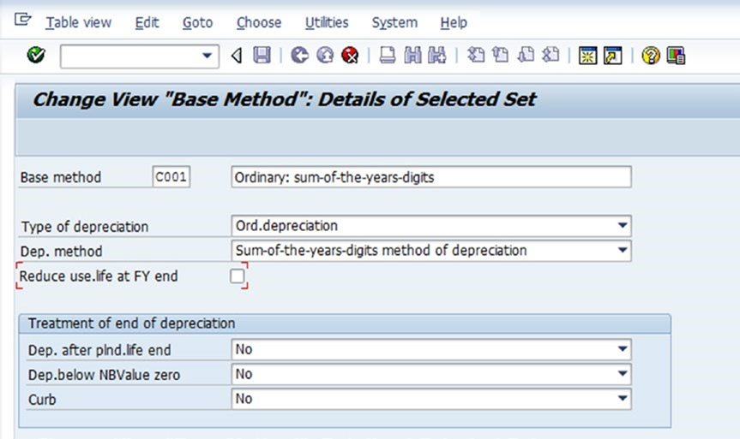

**Follow the below method to define:**

* ***Base method:*** Enter the four digits as the base method code and a description for newly defined base method in these fields.
* ***Type of depreciation:*** Enter the type of depreciation for the defined base method in this field. Using the drop-down arrow by the type of depreciation field from, ***ordinary depreciation, special tax depreciation, and interest***. Select ***Ordinary Depreciation*** from the list.
* ***Dep. Method:*** Using the drop-down by the ***Dep. Method field***, select ***Sum-of-the-years-digits*** method depreciation from the list of displayed depreciation methods.

The *Sum-of-the-years-digits* method of depreciation is based on the concept of calculating depreciation based on the sum of the number of years contained in an asset's useful economic life (UEL). This is often referred to as an accelerated depreciation technique. This method systematically allocates a higher depreciation amount to an asset in the earlier years of its useful life.

**Defining Declining-Balance Methods**

Declining-balance methods are calculated by applying a constant depreciation rate (for example, 10%, 15%, 20%, etc.) to the net book value (NBV) of an asset.

This method is also referred to as accelerated depreciation in the sense that it allocates higher depreciation expenses to an asset in the earlier years of its life.

To define declining-balancing methods, **SAP Reference IMG Menu Path**:

Financial Accounting (New) ➤ Asset Accounting ➤ Depreciation ➤ Valuation Methods ➤ Depreciation Key ➤ Calculation Methods ➤ Define Declining-Balance Methods.

The Change View ***“Declining-Balance Method”: Overview screen*** is displayed. Click the ***New Entries*** button at the top-left side of the screen to go to the standard screen where maintain the calculation methods for declining-balance methods.

The ***New Entries: Overview of Added Entries screen*** is displayed. Maintain the declining-balance methods using up to three digits and their descriptions, as shown in the below screenshot. Then specify a multiplication factor for determining the depreciation percentage rate and an upper limit for the depreciation percentage rate.

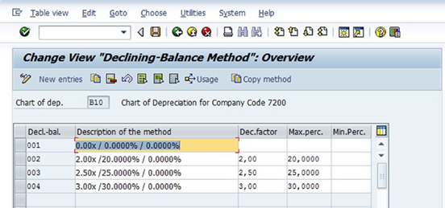

**Defining Multi-Level Methods**

A multi-level method is the process where the different percentage rates for depreciation for different years or periods. This method is more suitable when applying a higher rate in the calculation of assets in the initial years and subsequently using a lower rate in the later years.

For example, sometimes company uses a high rate in the earlier years when the asset is deemed to be more productive and a lower rate when the asset is deemed to be less productive as a result of wear and tear arising from the use of the asset.

SAP provides the flexibility to specify different rates of depreciation for different years or periods. The individual level represents the period of validity for each percentage rate of depreciation. At the end of the validity (year/period) of a percentage rate of depreciation, the system will automatically apply the next percentage rate of depreciation for the valid year/period (the next level). This is repeated systematically at the end of each year/period.

When defining multi-level methods for the depreciation calculation, Need to carry out the following functions:

* Maintain the multi-level method using a three-digit character as the multi-level method identifier and a description.
* Enter the parameters of the multi-level method.

Complete the following steps to define multi-level methods **SAP IMG Reference menu path**:

Financial Accounting (New) ➤ Asset Accounting ➤ Depreciation ➤ Valuation Methods ➤ Calculation Methods ➤ Define Multi-Level Methods.

* The Chart of Depreciation Selection screen pops up. This screen allows to specify the chart of depreciation that are using for your multi-level method.
* Enter your chart of depreciation (B10) in the ***ChDep*** field and click the ***Continue*** button at the bottom-left side of the screen. The Change View ***“Multilevel Method”: Overview screen*** appears containing the existing multi-level methods.
* Click the ***New Entries*** button at the top-left side of the screen. The ***New Entries: Details of Added Entries screen*** is displayed. This is where need to maintain multi-level methods.

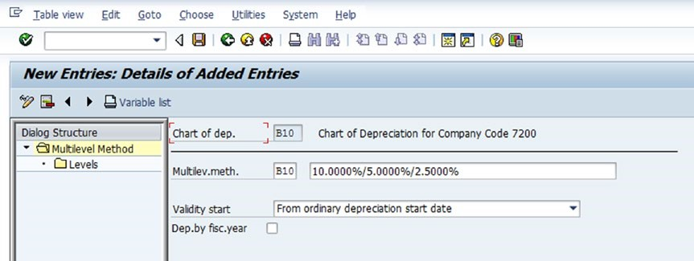

Update the following fields as below:

* ***Chart of Dep.:*** The chart of depreciation that is used for the multi-level method is defaulted by the system from the specification when specifying the chart of depreciation (B10).
* ***Multilev.Meth:*** Specify the identification key (B10) that needs to use for the multi-level method and enter a brief description that best describes the multi-level method.
* ***Validity Start:*** Here is the flexibility of determining whether the defined validity period begins with:
  + Capitalization date
  + Ordinary depreciation starts date.
  + Special depreciation start date.
  + Original acquisition data of AUC (Asset Under Construction)
  + Changeover year.
* Use the drop-down arrow by the Validity Start field to display the list of validity start options: Select Ordinary Depreciation Start Date from the list. This will allow to calculate the depreciation using the multi-level method technique applying ordinary depreciation principles.
* Click the ***Enter*** button at the top-left side of the screen to confirm if the system accepts the entries. Then save the work.
* The next step in this activity is to specify the levels for the multi-level method. To do this, double-click the ***Levels*** folder on the left pane of the screen. The Change View ***“Levels”: Overview screen*** is displayed.
* Click the ***New Entries*** button at the top-left side of the screen. The ***New Entries: Overview of Added Entries screen*** is displayed. This is where specifying the levels for the multi-level method.

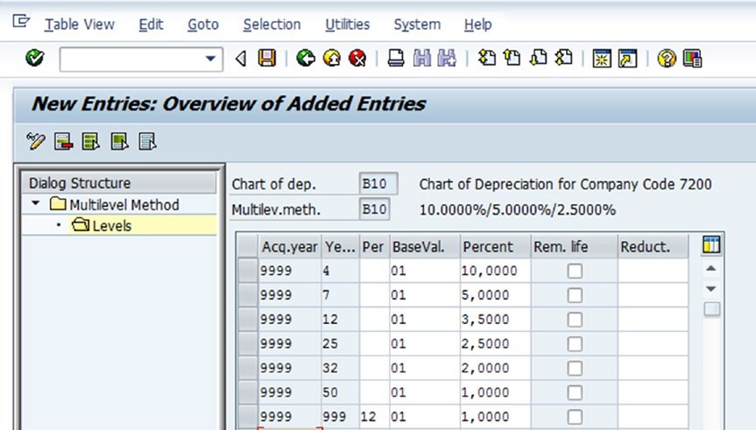

**Defining Maintain Period Control Methods**

Maintaining period control methods is important if a company wants to determine the depreciation start and end for the asset transactions.

This can be achieved by maintaining an adequate period control method for at least the four following transaction categories:

* Acquisition transactions
* Subsequent additional acquisitions/post-capitalization
* Retirements
* Intracompany transfers

Follow these steps to specify period control methods in the **SAP Reference IMG menu path:**

Financial Accounting (New) ➤ Asset Accounting ➤ Depreciation ➤ Valuation Methods ➤ Calculation Methods ➤ Maintain Period Control Methods.

* The Change View ***“Period Control”: Overview screen*** is displayed.
* Click the ***New Entries*** button at the top-left side of the screen. Update the screen using the information below or as per company requirements.

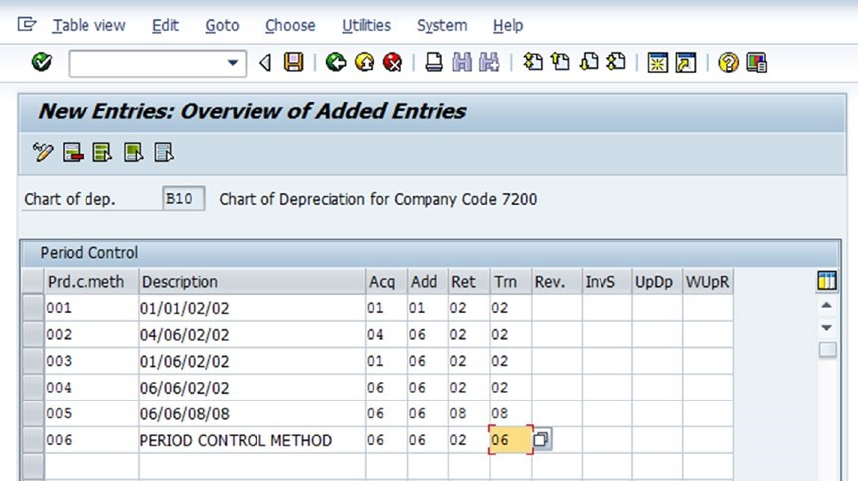

**Maintaining Depreciation Keys**

A depreciation key contains the calculation methods and the parameters that control ordinary and special depreciation. It also contains the parameter that controls other items like the scrap value of assets and the calculation of interest.

Depreciation keys are maintained by assigning calculation methods to the depreciation keys. The duration of depreciation can be split into several phases in the system so that when a changeover method is entered for a phase, the system moves automatically to the next phase when the conditions specified in the changeover method occur. The system then executes the depreciation calculation based on the calculation method for the phase.

When maintaining depreciation keys, carry out the following functions:

* Define additional depreciation keys using four-digit characters as the depreciation key. This includes a short description that best describes the depreciation key.
* Assign calculation methods to the depreciation keys and activate the depreciation key.

To define the depreciation key, follow the steps below. **SAP Reference IMG menu path:**

Financial Accounting (New) ➤ Asset Accounting ➤ Depreciation ➤ Valuation Methods ➤ Depreciation Key ➤ Maintain Depreciation Key.

* The Change View ***“Depreciation Key”: Overview screen*** is displayed containing the list of existing depreciation keys in the system.
* Click the **New Entries** button at the top-left side of the screen. The ***New Entries: Details of Added Entries screen*** is displayed. This screen will allow to enter a depreciation key and a description.

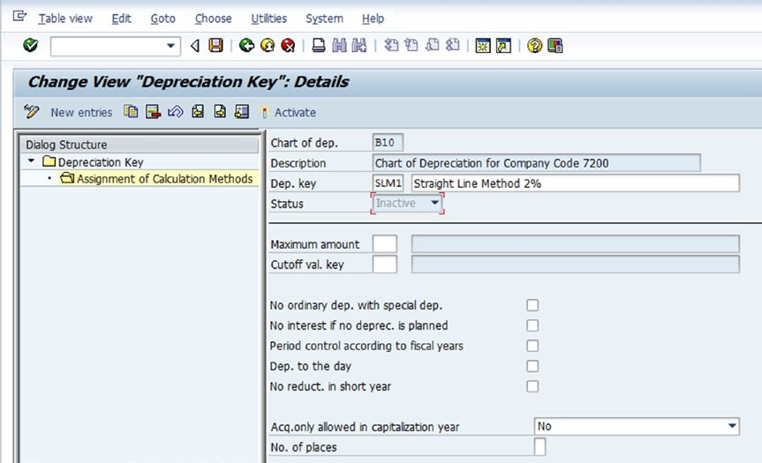

* The chart of depreciation and its description are set by default by the system. Enter the depreciation key and a description in the Dep.Key field. ***For example,*** SLM1 (Straight Line Method 2%)
* Click the ***Enter*** button at the top-left side of the screen to confirm if the system accepts the entries and then ***Save*** the depreciation key.

**Assigning Calculation Methods**

Once the depreciation keys is defined, the next step is to assign ***calculation methods to depreciation keys***.

* Assign the calculation method to a depreciation key, double-click the ***Assignment of Calculation Methods*** folder on the left pane of the screen. The Change View ***“Assignment of Calculation Methods”: Overview screen*** is displayed.
* Click the ***New Entries*** button at the top-left side of the screen. The ***New Entries: Details of Added Entries screen*** appears. This is where the assignment of calculation methods to depreciation keys.
* Update the following fields as below:
  + ***Dep Type:*** Enter the depreciation type as per the company requirements to assign to the depreciation key in this field. Can assign up to three depreciation types to a depreciation key (for example ***ordinary depreciation, special tax depreciation, and interest***). Using the drop-down menu by the Dep Type field, select Ordinary Depreciation from the list.
  + ***Phase:*** Enter the phase needed to apply the depreciation key in this field. Then this has up to three options. Using the drop-down menu by the field, select ***From the Start of Depreciation***.
  + ***Assignment of Calculation Methods:*** Enter the calculation method key needed as per company requirements to apply to the depreciation key for the ***base method, declining-balancing method, the period control method, and the multi-level methods*** in the respective fields.
  + Click the ***Enter*** button at the top-left side of the screen to confirm if the system accepts your entries and then ***Save*** your work.
  + The next step is to ***activate*** the depreciation key. Click the ***Back button*** twice to return to the ***Change View “Assignment of Calculation Methods”: Overview screen***. Showing the status is ***inactive***.
  + Click the ***Activate*** button to ***activate*** the depreciation key. The system will notify on the message bar that “***Key SLM1 was activated successfully in chart of depreciation B10”***

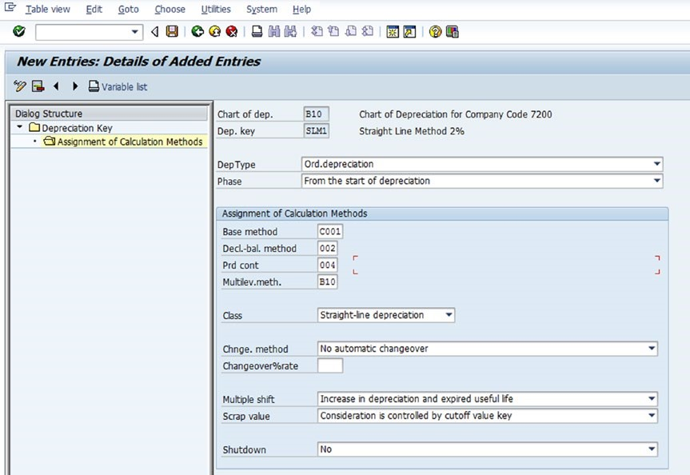

**Customizing Period Control**

This function dictates the period that determines the start and end of the depreciation of asset acquisitions and retirements. SAP comes with a standard control period, so don’t need to customize anything in this step. In period control, Also can maintain period control, define calendar assignments, define time-dependent period controls, and generate period controls.

To customize a period control, **SAP Reference IMG menu path:**

Financial Accounting (New) ➤ Asset Accounting ➤ Depreciation ➤ Valuation Methods ➤ Period Control ➤ Maintain Period Control.

The ***Change View “Period Control”: Overview screen*** appears containing the list of standard control period supplied by SAP.

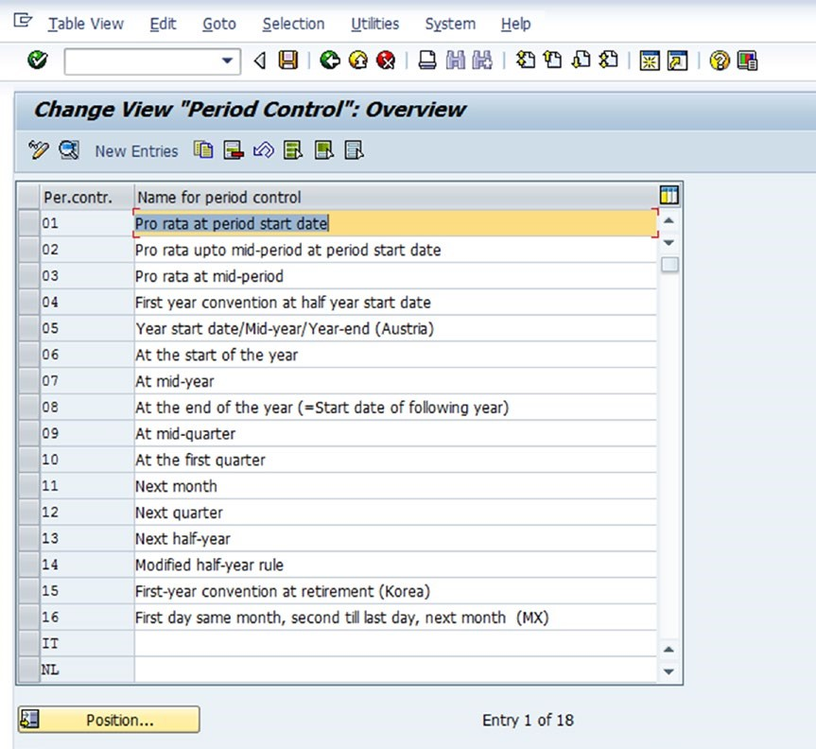

**Defining the Cutoff Value Key**

For some technical reasons or to meet legal requirements, it may become necessary to end the depreciation of some assets at a certain value level.

For example, a Company can end the depreciation of assets before the net book value reaches zero. The point where end the depreciation is referred to as ***scrap value or cutoff value***.

SAP enables to definition of a cutoff value for each depreciation area. This can by entering an absolute scrap value in the asset master record or by specifying a cutoff percentage in the cutoff value (calculation) key. SAP provides standard cutoff value keys that can adapt to meet the requirements by revising the time specifications of the scrap value keys that come with it.

To define the cutoff value key using the **SAP Reference IMG menu path:**

Financial Accounting (New) ➤ Asset Accounting ➤ Depreciation ➤ Valuation Methods ➤ Further Settings ➤ Define the Cutoff Value Key.

* The Change View ***“Cutoff Value Keys”: Overview screen*** is displayed, containing a list of cutoff values in the system.
* Click the ***New Entries*** button at the top-left side of the screen. The ***New Entries: Details of Added Entries screen*** is displayed. This is the screen where specifying the settings for the cutoff value key.
* Enter a three-digit character as the cutoff value key identifier in the Cutoff ***Val. Key*** field.
* Next, specify the date when the system to start calculating the percentages for the cutoff key in the Start Date of Calculation of Percentages section of the screen. In this section, There have four options choose from:
  + FROM asset capitalization date
  + FROM ordinary depreciation start date for the asset
  + FROM special depreciation start date for the asset
  + FROM original acquisition date for asset under construction

For the current activity, select FROM Asset Capitalization Date. This will allow the system to carry out calculations using the asset capitalization date.

* Click the ***Enter*** button at the top-left side of the screen to confirm if the system accepts the entries. The system will issue a warning on the status bar at the bottom of the screen that says ***”Choose the key from the allowed name space”***.
* Ignore the warning and click the ***Enter*** button again so the system will accept the entries. ***Save*** your work. The system will notify on the status bar at the bottom of the screen that ***“data was saved”.***
* Use the ***Back*** button at the top of the screen to return to the Change View ***“Cutoff Value Keys”: Overview screen***.
* Enter a description for the cutoff value key in the Name for Cutoff Value Key field.

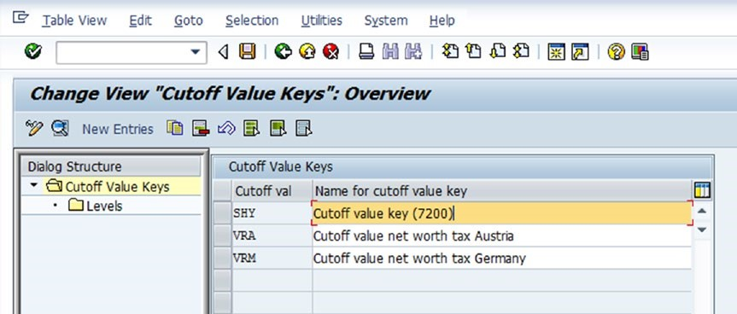

* Click the ***Enter*** button at the top-left side of the screen to confirm if the system accepted the entries and ***Save*** your work.
* The next step in this activity is to specify the levels for the cutoff value key. To do this, select the cutoff value key and double-click the ***Levels*** folder on the left pane of the screen. The Change View “***Levels”: Overview screen*** is displayed.
* Click the ***New Entries*** button at the top of the screen. The ***New Entries: Overview of Added Entries screen*** appears.
* Specify the Validity date and the Cutoff percentage.
* Click the ***Enter*** button at the top-left side of the screen to confirm the entries. Ignore any warnings and ***save*** the work

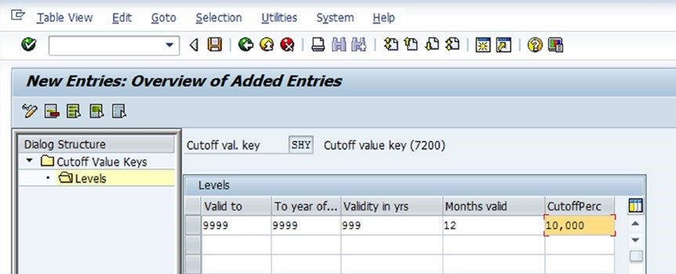

**Defining the Maximum Base Value**

This step is not necessary if the limited acquisition value is not required as a base for calculating depreciation. Limited acquisition value simply indicates that the system uses the maximum amount as the base value for depreciation.

When calculating depreciation, the system ***uses the acquisition value of the asset*** as the basis for calculating depreciation, if the acquisition value is below the specified maximum amount.

On the other hand, if the asset acquisition value exceeds the specified maximum amount you specified as the base value, the system will automatically use the asset acquisition value as the basis for calculating depreciation. Maximum base values are not delivered by SAP.

To define maximum base values, **SAP Reference IMG menu path**:

Financial Accounting (New) ➤ Asset Accounting ➤ Depreciation ➤ Valuation Methods ➤ Further Settings ➤ Define Maximum Base Value.

The Change View ***“Maximum base value”: Overview screen*** is displayed. Click the button at the top-left side of the screen. The ***New Entries: Overview of Added Entries screen*** is displayed. This is where that will carry out the actual specifications for the maximum base value.

**Specifying Asset-Specific Base Value Percentages**

This method is rarely used. This can specify the base value percentage rate as the base value for depreciation.

To specify asset-specific base value percentages, **SAP Reference IMG menu path**:

Financial Accounting (New) ➤ Asset Accounting ➤ Depreciation ➤ Valuation Methods ➤ Further Settings ➤ Specify Asset-Specific Base Value Percentages.

The ***Change View “Company Code”: Overview screen*** is displayed. On this screen specifying base value percentage for the company code to meet the requirements.

